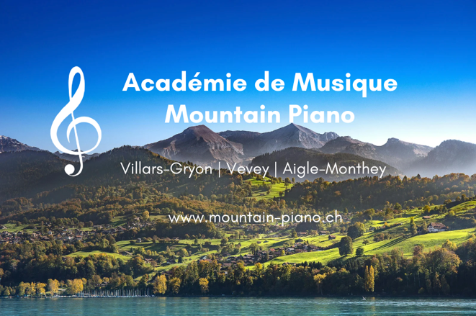**École de Musique Mountain Piano**

Académie de Musique **Mountain Piano**

***Making Music Addictive!***

Locations in Villars-Gryon, Vevey and Aigle-Monthey

E-Mail: [info@mountain-piano.ch](mailto:info@mountain-piano.ch)

Site: [www.mountain-piano.ch](http://www.mountain-piano.ch)

Date: 28.2.22

**Teaching Approach – INTERMEDIATE PIANO STUDETNS**

​

Teaching intermediate level students (particularly when they started as a beginner with us) is a hugely rewarding progress, particularly when seeing the student progress through the hurdles, books and grades from day one!

​

For intermediate level students of all ages, we offer 45- or 60 minute lessons. The lessons can occur in one of our locations in the Villars-Gryon/Vevey/Aigle-Monthey area.

​

Our approach for intermediate students vary and are catered to the student, but some general highlights include:

* Guaranteed progression from the first lesson
* Specific Exam training (e.g. ABRSM, Trinity)
* Two concerts per year and other potential performance opportunities
* Prices in line with national recommendations, access to school scholarship fund if needed
* Group collaboration opportunities
* Piano & Keyboard rental and purchasing opportunities

Some testimonials from intermediate students:

* ‘I listened to a recent teaching session in our house, and I was impressed. As a result of his teaching style, which is very much child led, my daughter has done extremely well. Finding a replacement as we have moved abroad will be hard’, ***Tania, Parent***
* "Nous, comme parents, recevons des commentaires réguliers (quelquefois écrit et de temps en temps aussi dans une manière informelle) du formation de nos deux enfants chez Mountain Piano à Villars. Et surtout, la prof a pris grand soin les soirs d'hiver, que mes enfants peuvent rentre à la maison en toute sécurité.’, ***Corinne, Parent of two students, Gryon***
* ‘If you are looking for a piano teacher for children, the team at Mountain Piano are the best people! ***Family of two students, Chesières***
* "I continue to make great progress here at Mountain Piano, with a great and supportive teacher. And I get lots of opportunities such as concerts that help me improve learning piano.", ***Felix, intermediate level student, Villars***

Contact details:

* E-Mail: [info@mountain-piano.ch](mailto:info@mountain-piano.ch)

