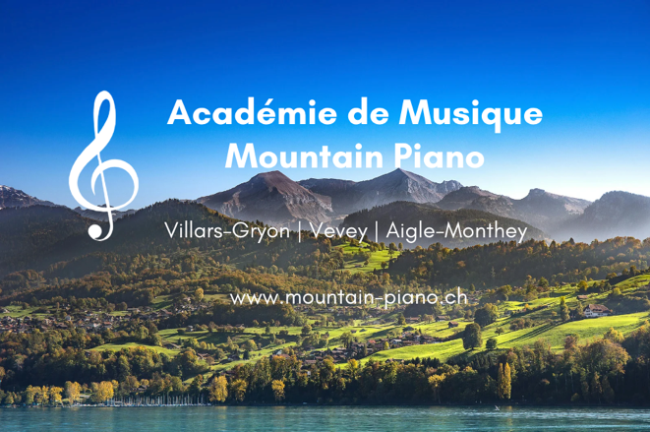**École de Musique Mountain Piano**

Académie de Musique **Mountain Piano**

***Making Music Addictive!***

Locations in Villars-Gryon, Vevey and Aigle-Monthey

E-Mail: [info@mountain-piano.ch](mailto:info@mountain-piano.ch)

Site: [www.mountain-piano.ch](http://www.mountain-piano.ch)

Date: 28.2.22

**Teaching Approach – ADVANCED PIANO STUDETNS**

​

Teaching advanced students allows for our most tailored and lenient approach to teaching. Students at this level are expected to have significant backgrounds and experience in many aspects in the instrument, and will receive expert guidance from our teachers. Remember - all professional concert pianists still have teachers- there is always more to learn!

​

We offer lessons for advanced students of all ages, in 60, 75 or 90 minute lessons. The lessons can occur in one of our studios in the Villars-Gryon / Vevey /Aigle-Monthey area.

​

Our approach for advanced students vary and are catered to the student, but some general highlights include:

* Tuition from an expert in your favourite/ preferred piano style (jazz, classical etc.)
* Various concerts & performance opportunities throughout the year
* Teaching locations with high-quality grand pianos (Steinway, Yamaha)
* ABRSM/ Trinity/ AVCEM exam training - with many student success stories
* Master-classes & competition preparation for certain repertoire
* Full Scholarship for certain advanced students every year.
* Join an international group of talented students taught under the patronage of Mountain Piano teachers

Some testimonials from intermediate students:

* ‘Sam and his team at Mountain Piano are highly regarded in the area and are highly skilled at what they do. The school attracts an outstanding caliber of teachers to teach at their school- alongside successfully delivering high-quality services to demanding international schools and students alike.’ ***Advisor to Mountain Piano, December 2021***
* “The innovative, student-led, yet traditionally grounded teaching approach of my teacher at Mountain Piano is one to be admired, but equally to be taken great advantage of! He has been an excellent teacher and general mentor for me and couldn’t recommend and thank him more!”, ***Ritam, advanced student***
* ‘Oustanding advice and guidance on my advanced repertoire is standard from my teacher.’ ***Richard, advanced student***
* **Countless exam success stories** - contact us for performance excerpts or to get refrerences from successful students themselves

Contact details:

* E-Mail: [info@mountain-piano.ch](mailto:info@mountain-piano.ch)

