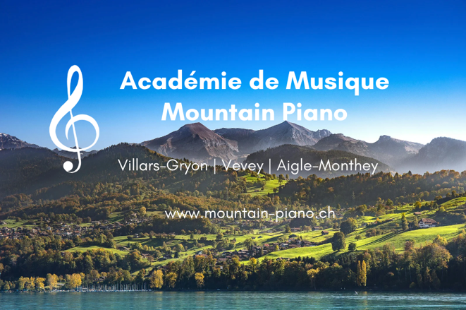**École de Musique Mountain Piano**

Académie de Musique **Mountain Piano**

***Making Music Addictive!***

Locations in Villars-Gryon, Vevey and Aigle-Monthey

E-Mail: [info@mountain-piano.ch](mailto:info@mountain-piano.ch)

Site: [www.mountain-piano.ch](http://www.mountain-piano.ch)

Date: 28.2.22

**Teaching Approach – BEGINNER PIANO STUDETNS**

Most of our students have either started with us, or still are, beginners at Mountain Piano. We offer lessons for beginners of all ages, in 30, 45 or 60 minute lessons. The lessons can occur in English, French or German in one of our four locations in the Villars/Gryon/Aigle area.

​

We are frequently asked when is the best time to start lessons- we believe the right age to start is when your child is **at least six years old**. Beforehand, we recommend them taking part in our **group piano lessons**.

​

Our approach for beginners vary and are catered to the student, but some general highlights include:

* Guaranteed progression from the first lesson
* Two concerts per year to showcase their progress
* Prices in line with Vaud recommendations, Access to the scholarship fund if necessary
* 5% siblings discount, 7.5% discount for third child
* Cheap 6-12 month long piano & Keyboard rental discounts

Some testimonials from beginner students:

* ‘My son loves lessons with his teacher at Mountain Piano. Being so young he is difficult to teach and after trying a couple of other teachers with no progression, we tried lessons with Sam, head and teacher at Mountain Piano. Since then, he has performed at a concert (despite being only five years old), and loves lessons so much that he now has two to three a week!’, ***Mother of beginner student, Villars***
* ‘Thank you for all the new things you’ve taught us on the piano. We really appreciate it, we really like the lessons you prepare for us. Thank you!’ ***From two students, Villars***
* ‘He very much enjoys his teachers teaching style and has made impressive progress in a short amount of time’, ***Beginner student, Villars***
* ‘My dream of performing a piece I had self-taught myself during lockdown on a grand piano in a concert hall came true! I thoroughly enjoyed the opportunity and am eternally grateful to the Mountain Piano team for facilitating it, and look forward to performing at many more concerts and improving my pianistic abilities for many years to come with them! ***Adult beginner student, Gryon***
* ‘As an adult beginner, I needed to find an incredibly patient teacher, as well as one that could be very flexible with times as I also work and have children. The team at Mountain Piano were able to facilitate my needs and I really enjoy my lessons, and am making great progress!’, ***Nina, Adult student, Villars***

